[www.oracle.com/academy](http://www.oracle.com/academy)

Database Programming with SQL 17-1: Controlling User Access Practice Solutions

Try It / Solve It

1. What are system privileges concerned with?

# Solution:

System privileges are concerned with access to the database at the system level such as creating users, usernames and passwords, allocating disk space to users, and granting the system privileges that users can perform such as creating tables, views and sequenc- es. (DDL and DCL)

1. What are object privileges concerned with?

# Solution:

Object privileges are concerned with access and use of the database objects and the ac- tions that those users can have on the objects. (DML and basic SQL)

1. What is another name for object security?

# Solution:

Object security is also known as data security.

1. What commands are necessary to allow Scott access to the database with a password of tiger?

# Solution:

CREATE USER scott IDENTIFIED BY tiger ;

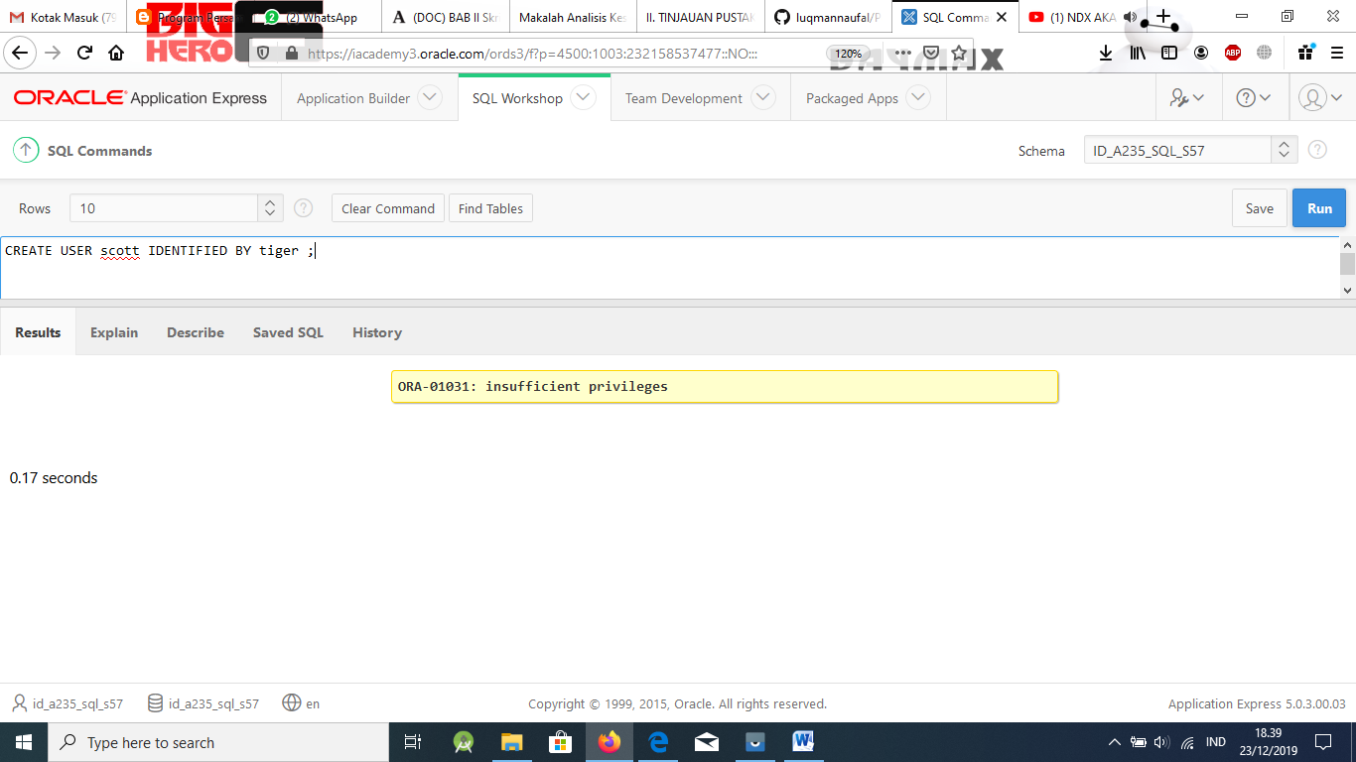

GRANT create session TO scott;

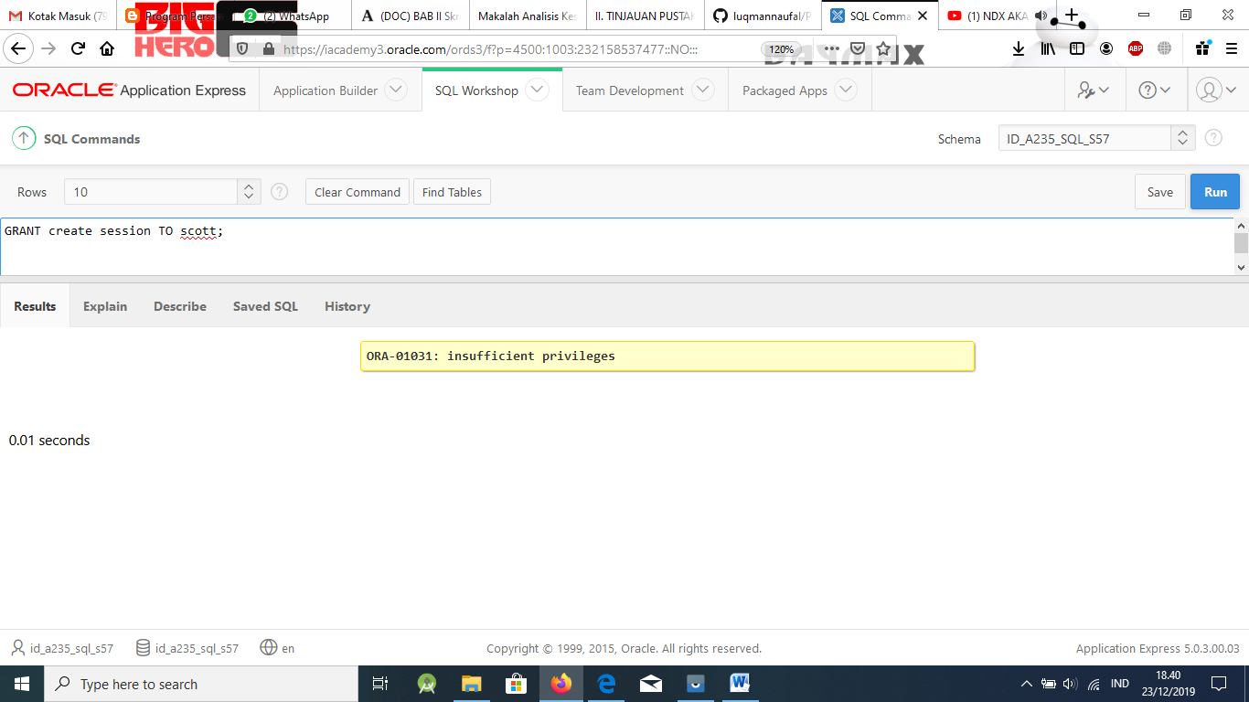

1. What are the commands to allow Scott to SELECT from and UPDATE the d_clients table?

# Solution:

GRANT select, update ON d_clients TO scott;

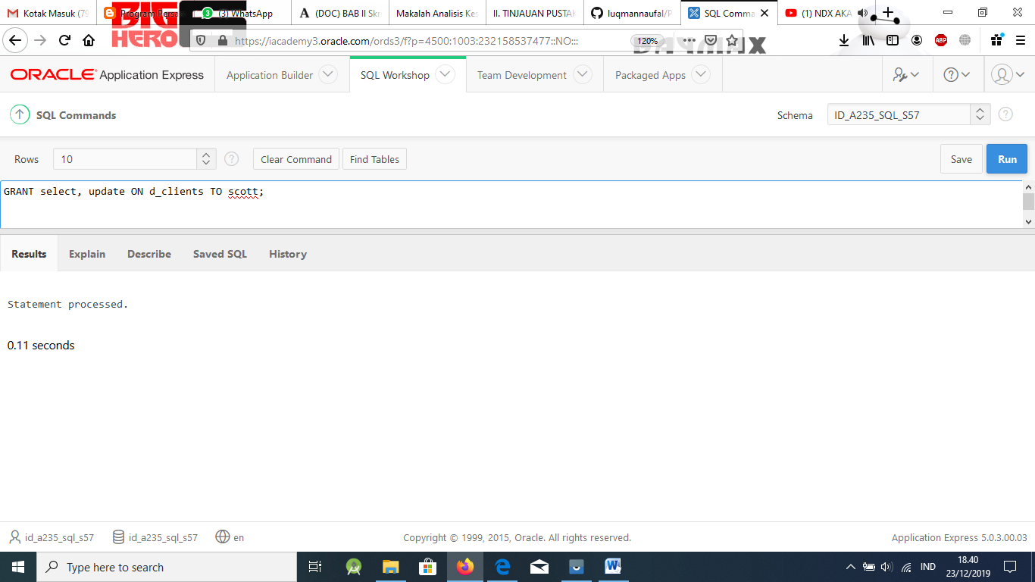

1. What is the command to allow everybody the ability to view the d_songs table?

# Solution:

GRANT select ON d_songs TO PUBLIC;

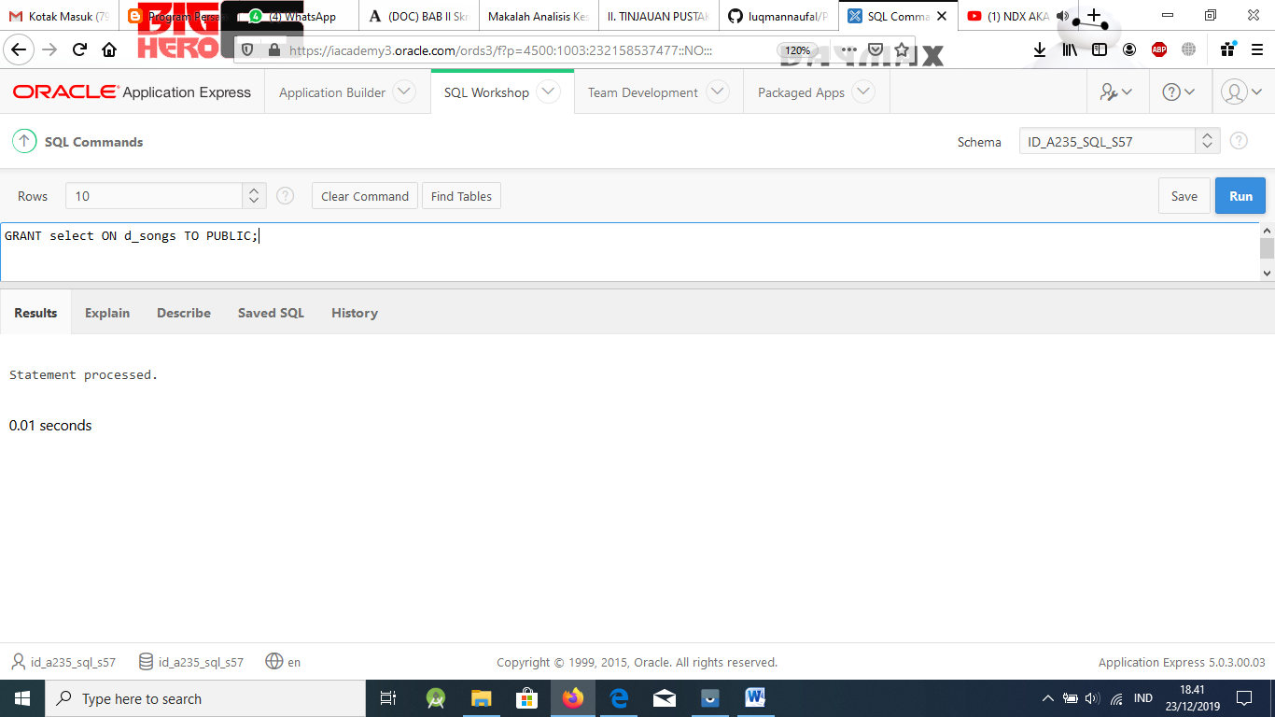

1. Query the data dictionary to view the object privileges granted to you the user.

# Solution:

Use the HTML DB SQL Workshop Data Dictionary Browser to enter the search for US- ER_TAB_PRIVS_RECD. Click the magnifying glass to view table privileges received.

or

SELECT * FROM user_tab_privs_recd ;

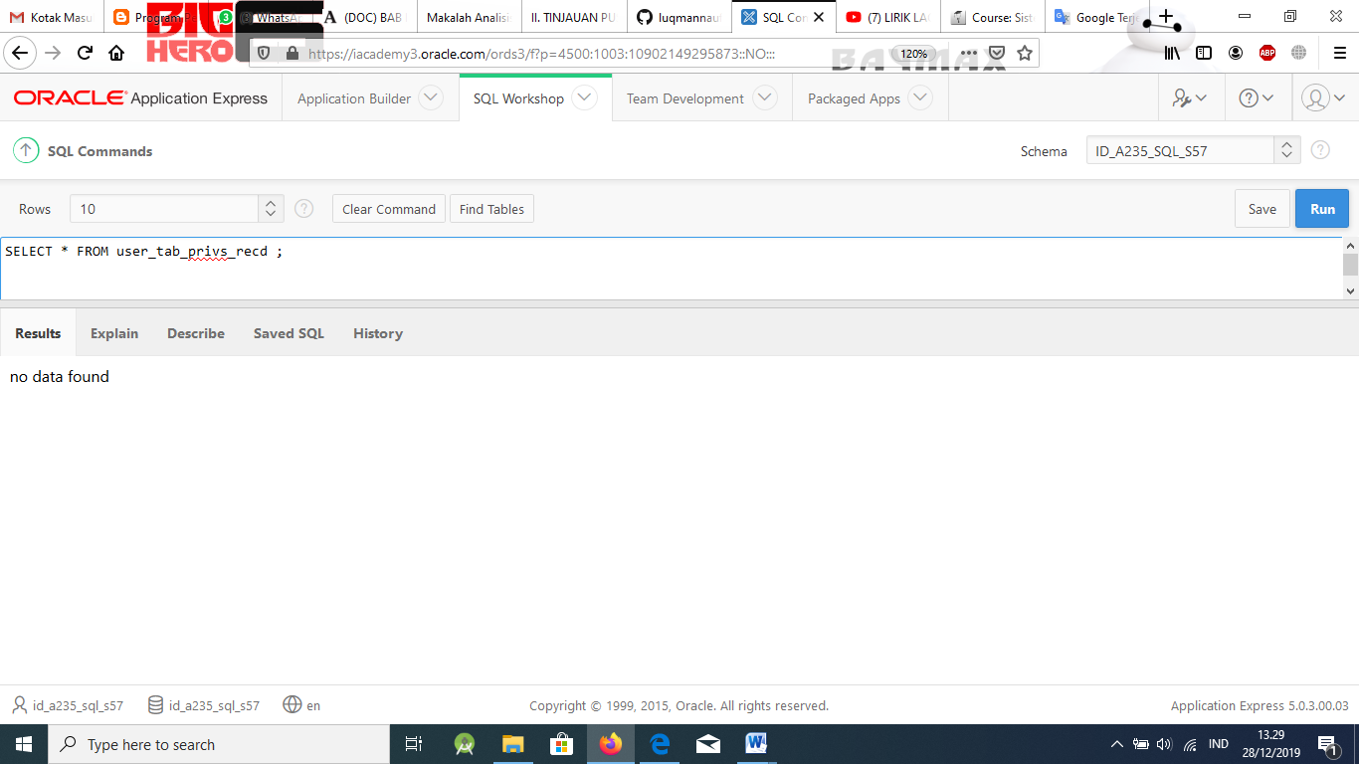

1. What privilege should a user be given to create tables?

# Solution:

The CREATE TABLE privilege.

1. If you create a table, how can you pass along privileges to other users just to view your table?

# Solution:

You grant them the SELECT privilege.

1. What syntax would you use to grant another user access to your copy_employees table?

# Solution:

GRANT SELECT

ON copy_employees TO username;

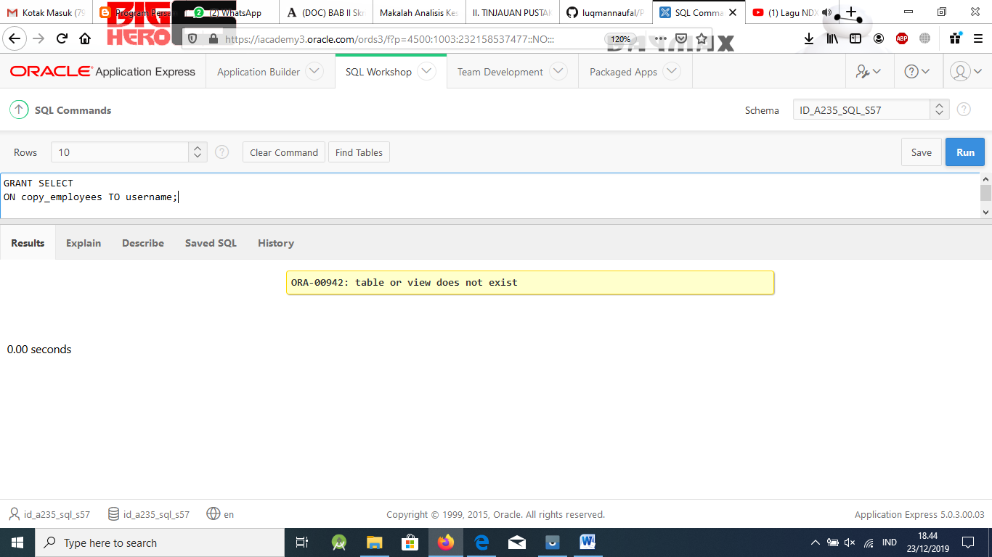

1. How can you find out what privileges you have been granted for columns in the tables be- longing to others?

# Solution:

Query the USER_COLS_PRIVS_RECD

[www.oracle.com/academy](http://www.oracle.com/academy)

# Database Programming with SQL

17-2: Creating and Revoking Object Privileges Practice Solutions

Try It / Solve It

1. What is a role?

## Solution:

A role is a named group of related privileges that can be granted to the user.

1. What are the advantages of a role to a DBA?

## Solution:

Easier to grant, maintain and revoke privileges thus saving time.

1. Give the ability for another user in your class to look at one of your tables. Give them the right to let other students have that ability.

## Solution:

GRANT select ON tablename TO username

WITH GRANT OPTION;

1. You are the DBA. You are creating many users who require the same system privileges. What should you use to make your job easier?

## Solution:

Create a ROLE containing the system privileges and grant the role to users.

2

1. What is the syntax to accomplish the following?
   1. Create a role of manager that has the privileges to select, insert and update and delete from the employees table

## Solution:

CREATE ROLE manager

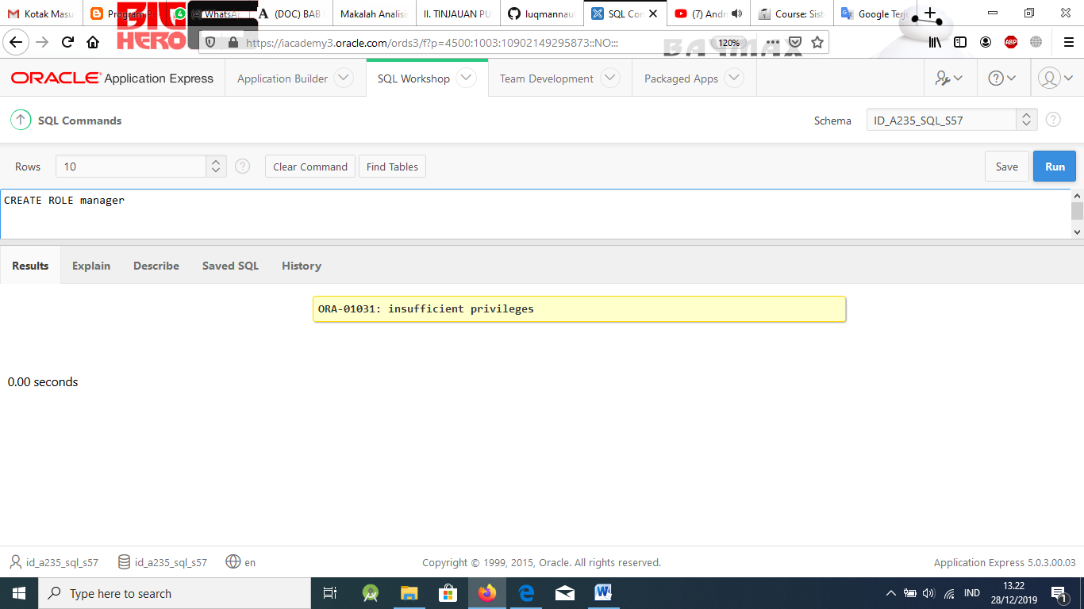

GRANT select, insert,update,delete ON employees TO manager ;

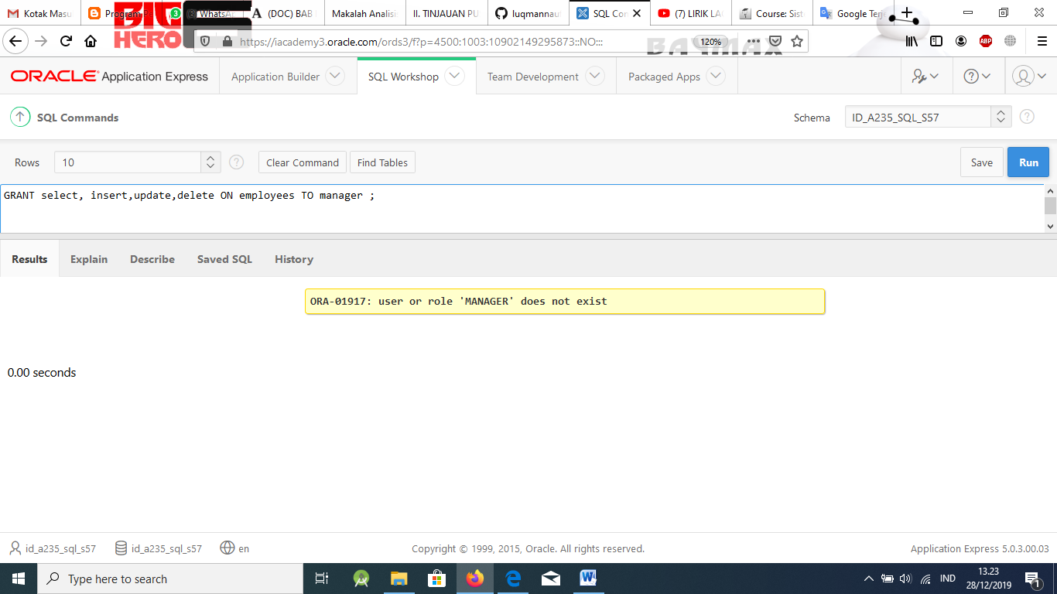

* 1. Create a role of clerk that just has the privileges of select and insert on the employees table

## Solution:

CREATE ROLE clerk ;

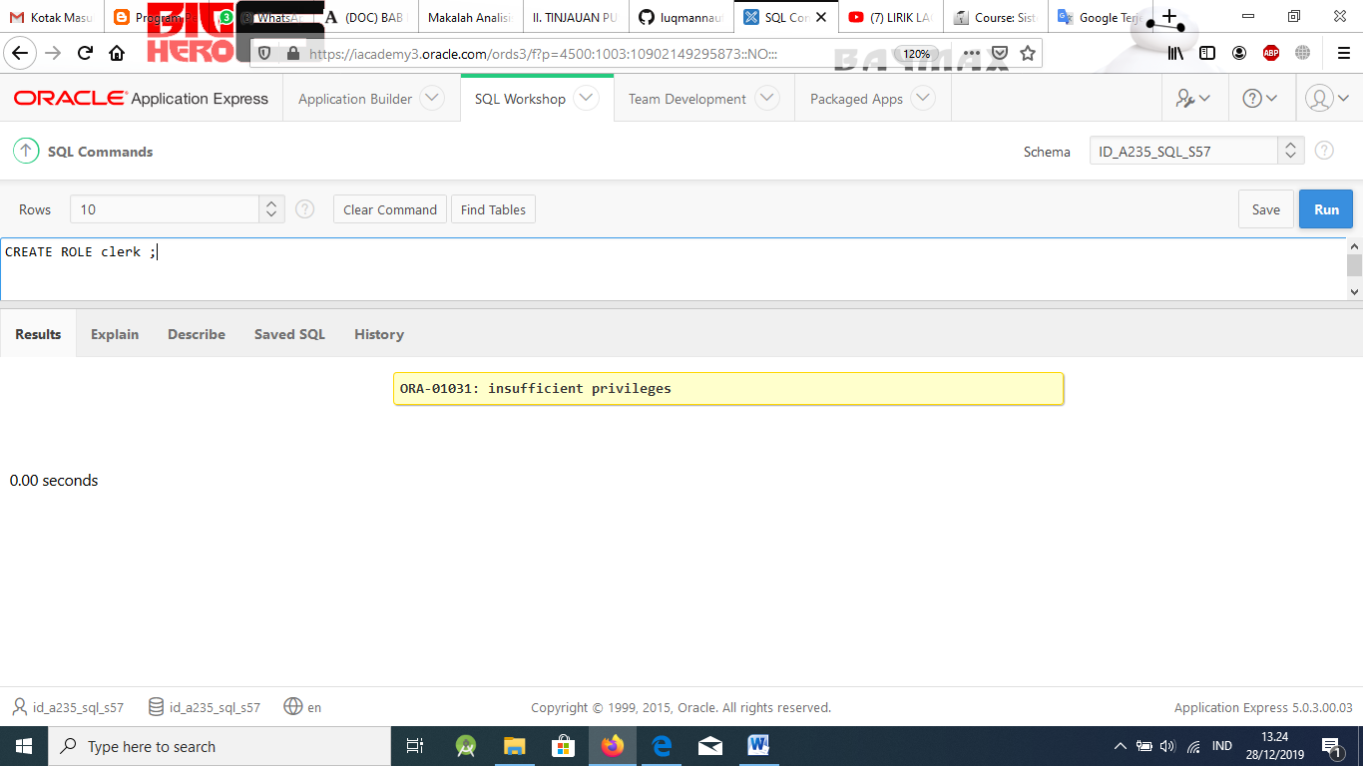

GRANT select, insert ON employees TO clerk;

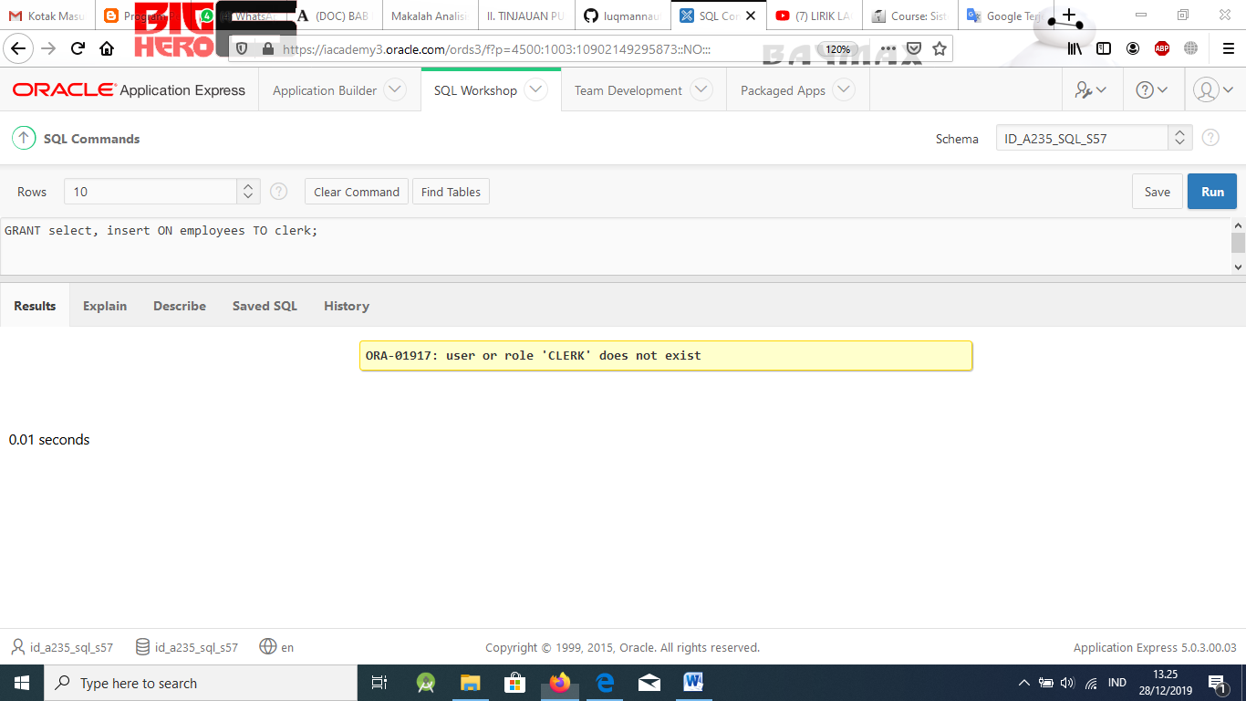

* 1. Grant the manager role to user scott

## Solution:

GRANT manager TO scott ;

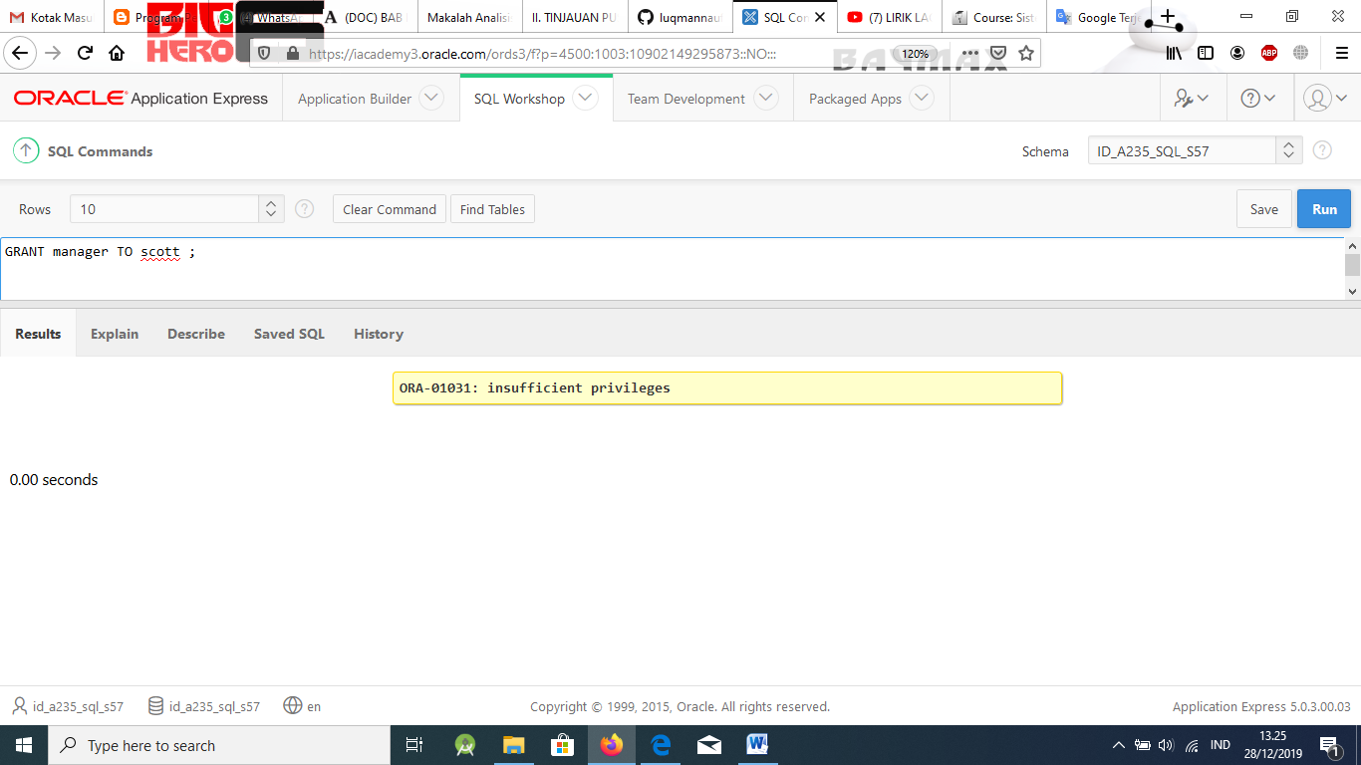

* 1. Revoke the ability to delete from the employees table from the manager role

## Solution:

REVOKE delete ON employees FROM manager ;

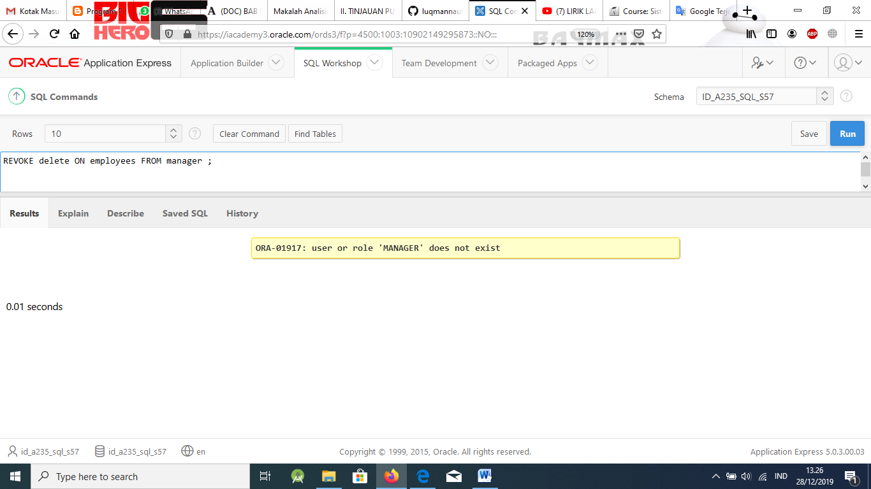

1. What is the purpose of a database link?

## Solution:

A database link is a pointer that defines a one-way communication path from one Oracle database to another Oracle database.

[www.oracle.com/academy](http://www.oracle.com/academy)

Database Programming with SQL 17-3: Regular Expressions Practice Solutions

Try It / Solve It

1. Working with the employees table, and using regular expressions, write a query that re- turns employees whose first name starts with a “S” (uppercase) followed by either a “t” (lowercase) or “h” (lowercase).

# Solution:

SELECT first_name, last_name FROM employees

WHERE REGEXP_LIKE (first_name, '^S(t|h).')

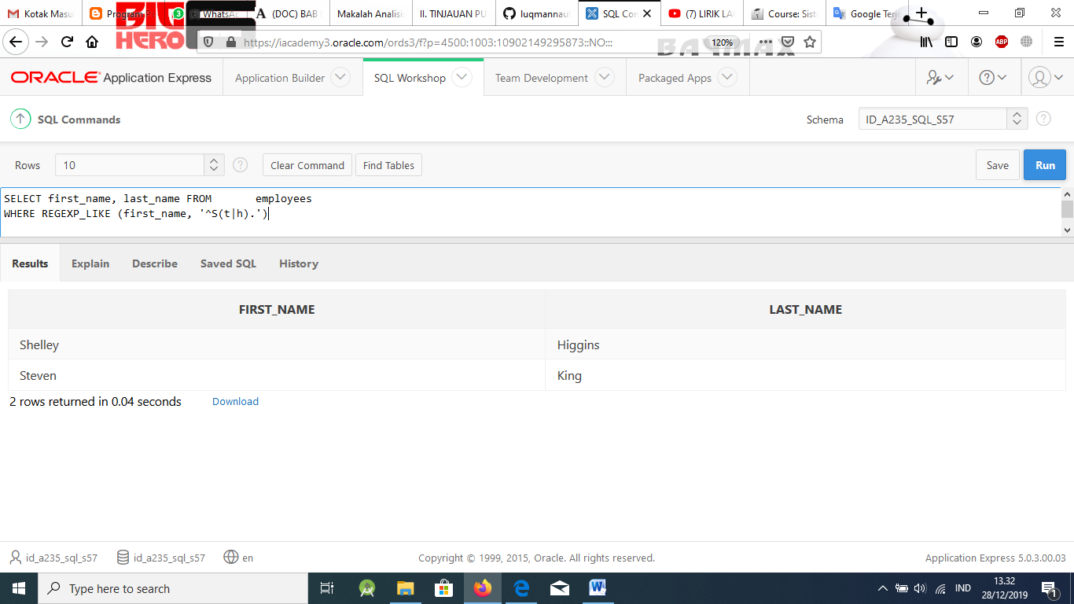

1. Investigate the LOCATIONS table.
   1. Describe the table.

# Solution:

DESC locations

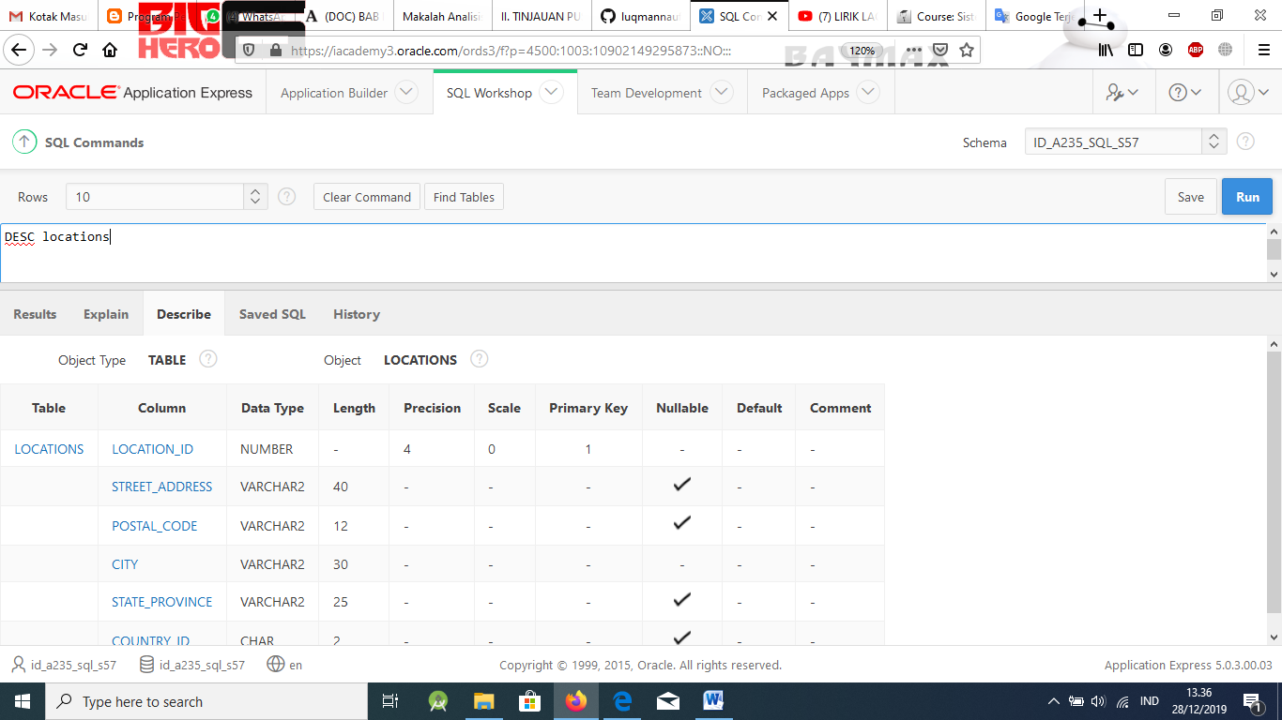

* 1. Perform a select that returns all rows and all columns of that table.

# Solution:

SELECT *

FROM locations;

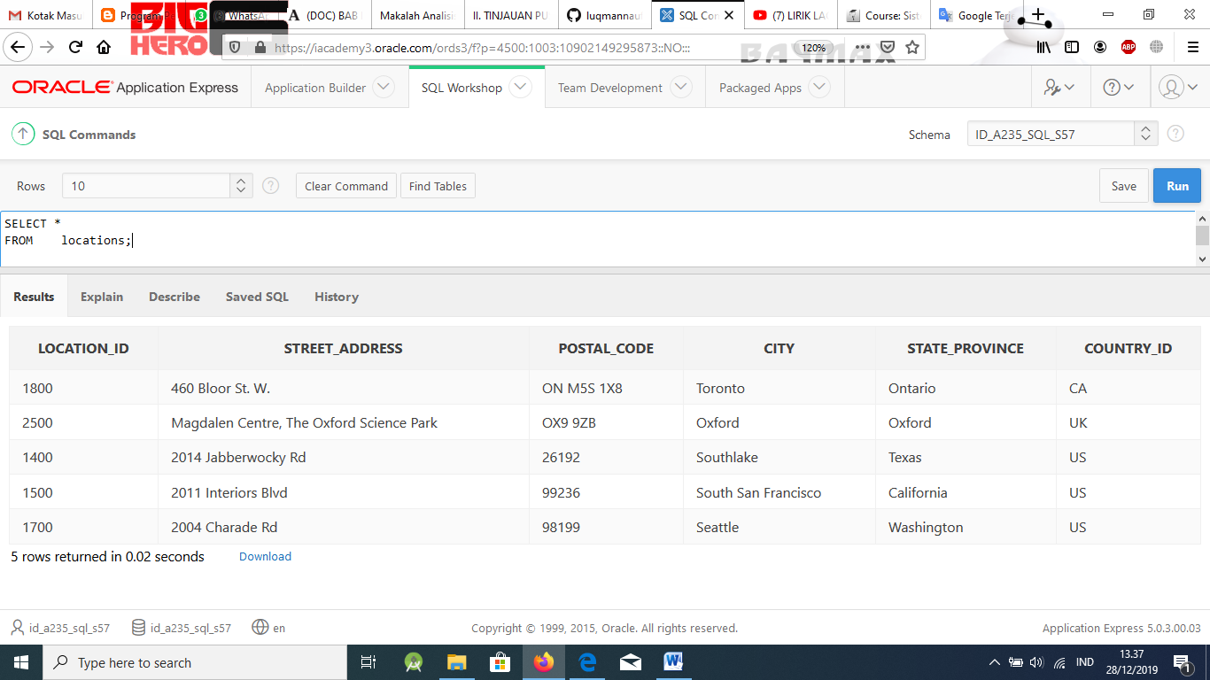

* 1. Write a query using regular expressions that removes the spaces in the street_address column in the LOCATIONS table.

# Solution:

SELECT REGEXP_REPLACE (street_address, ' ','') FROM LOCATIONS

